# **Implementing Quality Measurement – Clear Voice**

## Prerequisites:

1. **SQL server**
2. **Net framework 4.5**
3. **IIS**

## Steps:

### Taking backup of databases (5)

* Databases to be backed up: QualityMeasurement, QualityMeasurementLog, QualityMeasurementTransactionDB, QualityMeasurementConfigurationOnline.
* Steps for backup:

1. Open Microsoft SQL Server Engine.

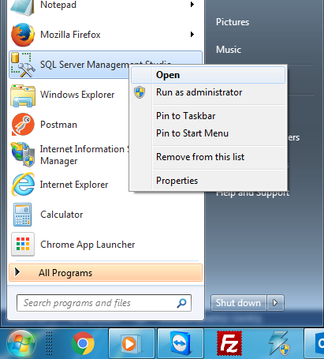

1. Connect to the instance you want to take backup from.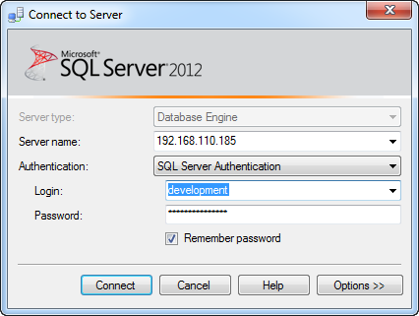
2. Right click the database you want to back and choose : Tasks>>Back Up …

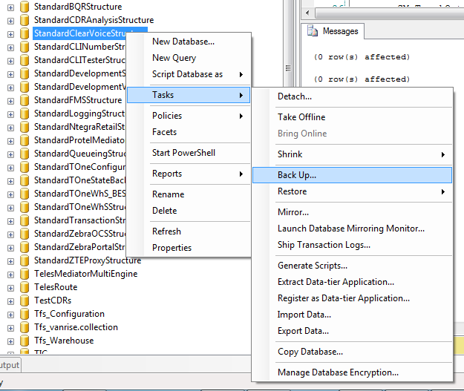

1. Choose destination you want to back your file to.

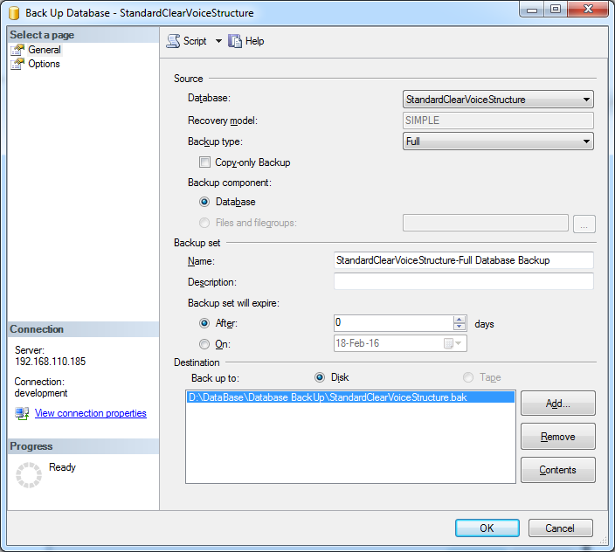

### Restoring backup files of databases (5)

* Steps for Restore:

1. Right click the “Databases” folder and choose : Restore Backup

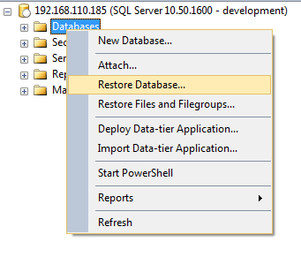

1. Choose the source to be device and then locate the file you have already backed up.

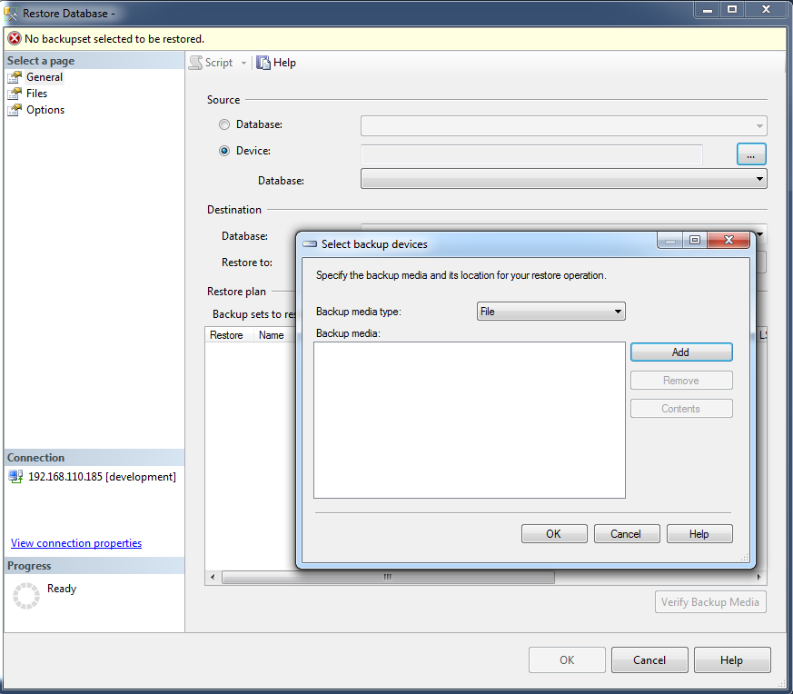

1. Choose the last backup set to be restored, and click ok finally.
2. Apply post scripts for databases restored, each script should be executed in its database.

### Get Latest Published Versions from

Clear Voice website new version will be released under: \\192.168.110.185\Fixes\WebSite\ClearVoice\20160205\

* Clear Voice service new versions will be released under: \\192.168.110.185\Fixes\WebSite\ClearVoice\Runtime\20160205\

### Update configuration files for both website and runtime

* Config Files for website and runtime are called: Web.config and QualityMeasurement.DevRuntime.exe.config consecutively



* + For Both website and runtime config files you should update the credentials of connection strings to match the credentials you need

### Publish website and runtime

* Publishing Website:
  1. Click Start, point to Settings, and then click Control Panel.
  2. Double-click Administrative Tools, and then double-click Internet Services Manager.
  3. Create new pool

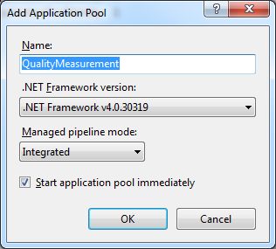

* 1. Click Action, point to New, and then click Web Site.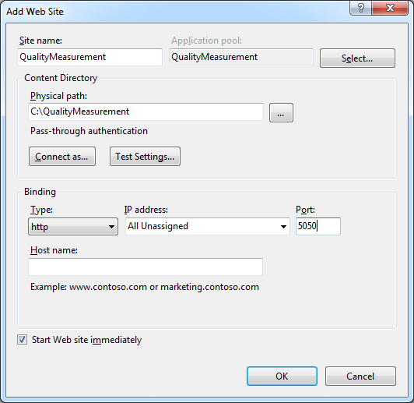
  2. After the Web Site Creation Wizard starts, click next.
     1. Type Name for the Web site TIC.
     2. Application Pool: choose the new pool created.
     3. Under physical path, either type the path to the folder that is holding the Web site documents or click Browse to select the published version folder
     4. Set the port number 5050, or choose different port if this port is not available
     5. Click Finish.
* Publishing Runtime:
  1. Click Start, type Task Scheduler and press enter.
  2. Choose from actions **Create Task**.
  3. After the Task creation wizard starts.
     1. Type name for the task to be created QualityMeasurement Runtime, then click ok.

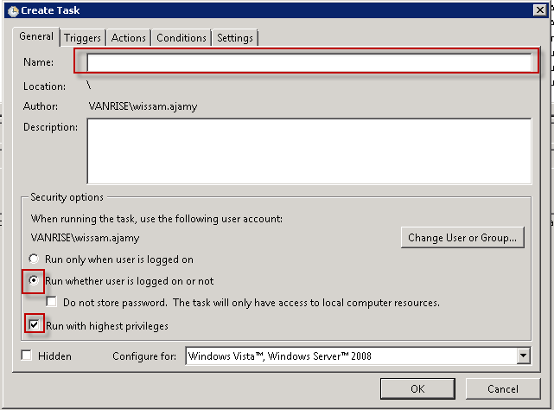

* + 1. Triggers: at start up, then click ok.

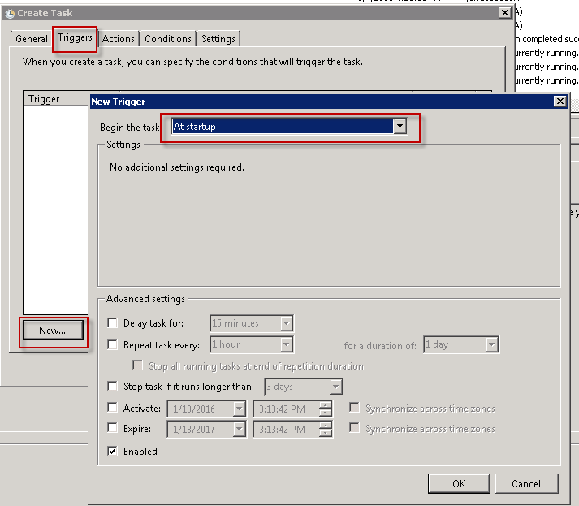

* + 1. Actions: start a program, Point to exe of runtime called QualityMeasurement.DevRuntime.exe, then click ok.

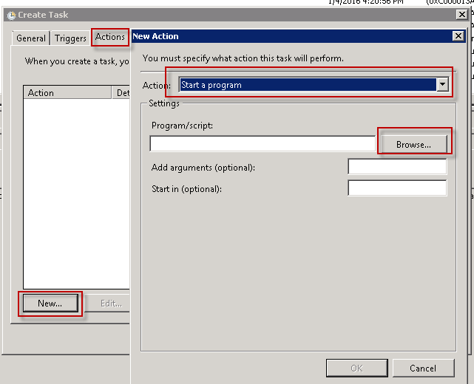

* + 1. Settings: uncheck stop the task, check if the task fails and update number of times, then Finish.

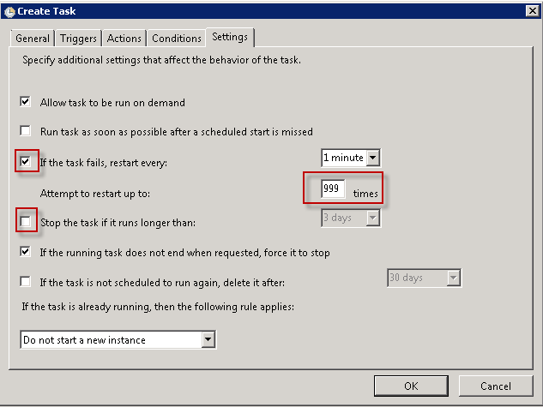

### Create Scheduler tasks for initiate tests and get results

